**FINGER PRINT BASED VOTING MANAGEMENT**

**SYSTEM**

A PROJECT REPORT

*Submitted by*

**KASHISH SINHA [Reg No:RA2111003011710] MANOJ R [Reg No:RA2111003011714]**

**ESWAR KILARI [Reg No:RA2111003011755] BANDARU SAI SRI VEER [Reg. No:RA2111003011789]**

**VELLANKI VENKAT ADITYA [Reg. No:RA2111003011799]**

*Under the Guidance of*

**Dr. Nikkath Bushra**

Assistant Professor, Department of Computing Technologies

*in partial fulfillment of the requirements for the degree of*

**BACHELOR OF TECHNOLOGY**

**in**

**COMPUTER SCIENCE AND ENGINEERING**



**DEPARTMENT OF COMPUTING TECHNOLOGIES COLLEGE OF ENGINEERING AND TECHNOLOGY SRM INSTITUTE OF SCIENCE AND TECHNOLOGY KATTANKULATHUR– 603 203**

**NOVEMBER 2023**



## SRM INSTITUTE OF SCIENCE AND TECHNOLOGY KATTANKULATHUR–603 203

**BONAFIDE CERTIFICATE**

Certified that 18CSP109L / I8CSP111L project report titled “**FINGER PRINT BASED VOTING MANAGEMENT SYSTEM**” is the bonafide work of **KASHISH SINHA [RegNo:RA2111003011710], MANOJ.R, [RegNo:RA2111003011714], ESWAR KILARI [RegNo:RA2111003011755], B. SAI SRI VEER [RegNo:RA2111003011789], V. VENKAT ADITYA**

**[RegNo:RA2111003011799]** who carried out the project work under my supervision. Certified further, that to the best of my knowledge the work reported here does not form part of any other thesis or dissertation on the basis of which a degree or award was conferred on an earlier occasion for this or any other candidate.

**Dr. NIKKATH BUSHRA**

**SUPERVISOR**

Assistant Professor

Department of Computing Technologies

**Dr. M. PUSHPALATHA**

**HEAD OF THE DEPARTMENT**

Department of Computing Technologies

 Department of Computing Technologies

**SRM Institute of Science and Technology Own Work Declaration Form**

**Degree/Course :** B.Tech in Computer Science

**Engineering Student Names:** KASHISH SINHA, MANOJ R,

ESWAR KILARI, B.SAI SRI VEER,

V. VENKAT ADITYA

**Registration Number:** RA2111003011710, RA2111003011714,

RA2111003011755, RA2111003011789 RA2111003011799

**Title of Work :** Finger Print Based Voting Management System

I/We here by certify that this assessment compiles with the University’s Rules and Regulations relating to Academic misconduct and plagiarism, as listed in the University Website, Regulations, and the Education Committee guidelines.

I / We confirm that all the work contained in this assessment is our own except where indicated, and that we have met the following conditions:

* Clearly references / listed all sources as appropriate, Referenced and put in inverted commas all quoted text (from books, web,etc.)
* Given the sources of all pictures, data etc that are not my own.
* Not made any use of the report(s) or essay(s) of any other student(s)either past or present, Acknowledged in appropriate places any help that I have received from others (e.g fellow students, technicians, statisticians, external sources)
* Compiled with any other plagiarism criteria specified in the Course hand book / University website

I understand that any false claim for this work will be penalized in accordance with the University policies and regulations.

|  |
| --- |
| **DECLARATION:** |
| I am aware of and understand the University’s policy on Academic misconduct and plagiarism and I certify that this assessment is my / our own work, except where indicated by referring, and that I have followed the good academic practices noted above.  **Date: 14.11.2023** |
| **Student 1 Signature:**  **Student 2 Signature:**  **Student 3 Signature:**  **Student 4 Signature:**  **Student 5 Signature:** |

**ACKNOWLEDGEMENT**

We express our humble gratitude to **Dr. C. Muthamizhchelvan**, Vice-Chancellor, SRM Institute of Science and Technology, for the facilities extended for the project work and his continued support.

We extend our sincere thanks to Dean-CET, SRM Institute of Science and Technology, **Dr.**

**T. V. Gopal**, for his invaluable support.

We wish to thank **Dr. Revathi Venkataraman**, Professor and Chairperson, School of Computing, SRM Institute of Science and Technology, for her support throughout the project work.

We are incredibly grateful to our Head of the Department, **Dr. M. Pushpalatha,** Professor, Department of Computing Technologies, SRM Institute of Science and Technology, for her suggestions and encouragement at all the stages of the project work.

We register our immeasurable thanks to our Course Faculty, **Dr. Nikkath Bushra**, Assistant Professor, Department of Computing Technologies, SRM Institute of Science and Technology, for leading and helping us complete the course work.

**ABSTRACT**

**The Fingerprint-Based Voting Management System (FBVMS) is a technologically advanced approach to enhance the efficiency and security of electoral processes. Leveraging biometric authentication, this system relies on the unique fingerprints of voters to verify their identity, ensuring a robust and tamper-resistant electoral environment. By integrating fingerprint recognition technology, the FBVMS mitigates the risks associated with fraudulent voting and impersonation, promoting the integrity of democratic processes. This innovative solution streamlines the voting process, reducing queues and enhancing accessibility for diverse voter demographics. The system not only enhances the accuracy of voter identification but also provides real-time data on voter turnout. Additionally, the FBVMS facilitates the rapid and secure tabulation of results, contributing to the overall transparency and credibility of elections. With its emphasis on biometric precision, efficiency, and integrity, the Fingerprint-Based Voting Management System represents a significant leap forward in the evolution of electoral technologies.**

**TABLE OF CONTENTS**

|  |  |  |  |
| --- | --- | --- | --- |
| **ABSTRACT** | | | **vi** |
|  | **LIST OF TABLES** | | **ix** |
|  | **LIST OF FIGURES** | | **x** |
|  | **LIST OF SYMBOLS AND ABBREVIATIONS** | | **xi** |
| **1**. | **INTRODUCTION** | | **1** |
|  | 1.1 | General | 1 |
|  | 1.2 | FINGER PRINT BASED BIOMETRICS | 2 |
|  | 1.3 | FINGER PRINT BASED VOTING MANAGEMENT SY | STEM 4 |
| **2** | **LITERATURE SURVEY** | | **11** |
|  | 2.1 | Motivation | 12 |
|  | 2.2 | Objective | 13 |
| **3** | **ARC MA** | **CHITECTURE AND ANALYSIS OF VOTING NAGEMENT SYSTEM** | **15** |
|  | 3.1 | Architecture Diagram | 15 |
|  | 3.2 | Frontend Design | 16 |
|  | 3.3 | Backend Design | 19 |
| **4** | **DESI BAS** | **GN AND IMPLEMENTATION OF FINGER PRINT D VOTING SYSTEM** | **22** |
|  | 4.1 | Dataset | 23 |
|  | 4.2 | Image Preprocessing | 25 |
| **5** | **RESULTS AND DISCUSSION**  5.1 Performance Analysis using Various Metrics | | **39**  39 |
|  | 5.2 | Comparison Between Existing Models | 45 |
| **6** | **CONCLUSION AND FUTURE SCOPE** | | **48** |
|  | 6.1  6.2 | Conclusion Future Scope | 49  49 |
|  | **REFERENCES** | | **50** |

**LIST OF FIGURES**

|  |  |  |
| --- | --- | --- |
| 1. | FINGER PRINT BASED BIOMETRIC SYSTEM | 3 |
| 2. | VOTING MANAGEMENT SYSTEM | 7 |
| 3. | ARCHITECTURE OF SIMPLE VOTING MACHINE | 8 |
| 4. | VOTING ARCHITECTURE | 9 |
| 5. | VOTING MANAGEMENT ARCHITECTURE | 15 |
| 6. | ARCHITECTURE DIAGRAM OF WEBSITE | 16 |

**LIST OF SYMBOLS AND ABBREVIATIONS**

|  |  |
| --- | --- |
| **FV System** | Fingerprint Voting System |
| **FBVS** | Fingerprint-Based Voting System |
| **FPS** | Fingerprint Polling System |
| **FIDV** | Fingerprint ID Voting |
| **BVTS** | Biometric Voting Technology System |
| **FPT** | Fingerprint Polling Technology |
| **FBES** | Fingerprint Biometric Election System |
| **FVS** | Fingerprint Verification System |
| **BFS** | Biometric Fingerprint System |
| **FPVS** | Fingerprint Voter System |

**CHAPTER 1**

**INTRODUCTION**

* 1. **INTRODUCTION TO FINGERPRINT BASED VOTING SYSTEMS DEFINITION:**

A fingerprint-based voting system utilizes biometric technology, specifically fingerprint recognition, to verify the identity of voters before allowing them to cast their votes.

Biometric Technology: Fingerprint recognition relies on unique patterns in individuals' fingerprints, providing a highly accurate method of identification.

* 1. **IMPLEMENTATION AND OPERATION:**

**Voter Registration Process:**

During enrollment, voters provide personal information and have their fingerprints scanned.

Fingerprint data is converted into templates and securely stored in a database.

**Voting Process:**

On election day, voters present themselves at polling stations for fingerprint scanning. The system matches the scanned fingerprint with pre-stored templates for verification. Upon successful verification, voters gain access to the voting machine to cast their votes. **Security Measures:**

Fingerprint data is encrypted for secure storage and transmission.

The system aims to reduce voter fraud by relying on the uniqueness of fingerprints.

### CONSIDERATION AND CHALLENGES:

**Challenges and Concerns:**

Privacy concerns may arise, necessitating strict measures to protect biometric data.

While generally accurate, fingerprint systems may have instances of false positives or negatives.

**Implementation Considerations:**

Costs involve acquiring biometric devices, database management, and personnel training. Adequate infrastructure, including reliable power and network connectivity, is crucial.

**Legal and Ethical Aspects:**

Legal frameworks are needed to regulate the use of biometric data for voting, addressing consent, ownership, and misuse.

Ethical considerations should ensure that biometric data is used solely for voter identification.

Fingerprint-based biometric technology stands at the forefront of modern security and identification systems, utilizing the distinctive ridge patterns on an individual's fingertips for foolproof authentication. Renowned for its unmatched accuracy and security, this cutting-edge technology has permeated various sectors. From bolstering access control and securing mobile devices to transforming the landscape of voting systems, fingerprint biometrics offers a multifaceted solution to identity verification.

The uniqueness of each person's fingerprints ensures a high level of precision, significantly reducing the risk of unauthorized access or identity fraud. Unlike traditional authentication methods such as passwords or PINs, fingerprints are inherently non-replicable, providing a robust defense against security breaches. This technology has become an integral component in enhancing user experience, offering a seamless and efficient means of access. Whether unlocking smartphones, accessing secure facilities, or authenticating financial transactions, the speed and convenience of fingerprint biometrics are unparalleled.

In the realm of voting systems, fingerprint-based biometrics plays a pivotal role in ensuring the integrity of electoral processes. By accurately verifying the identity of voters through their fingerprints, the technology minimizes the risk of fraudulent activities and impersonation, fostering a more transparent and trustworthy electoral environment. The adaptability and reliability of fingerprint-based biometric technology mark it as a cornerstone in the evolution of secure, efficient, and user- friendly identification methods across diverse applications and industries.

**CHAPTER 2**

**LITERATURE SURVEY ON FINGERPRINT-BASED VOTING SYSTEMS**

### MOTIVATION:

The motivation behind exploring fingerprint-based voting systems in the literature lies in the increasing need for secure, reliable, and efficient methods in electoral processes. Traditional voting systems may be susceptible to various challenges, including identity fraud, impersonation, and logistical issues. By incorporating biometric technology, specifically fingerprint recognition, into the voting process, researchers aim to enhance the overall security, accuracy, and integrity of elections. Fingerprint-based voting systems offer the potential to mitigate fraud, streamline the voter verification process, and contribute to the evolution of more robust electoral systems.

### OBJECTIVES:

**ENHANCING SECURITY**

**Literature Gap:** Previous studies have identified vulnerabilities in traditional voting systems, highlighting the potential for unauthorized access and manipulation.

Objective: Evaluate how fingerprint-based voting systems contribute to securing the electoral process by leveraging the unique and distinct nature of fingerprints for voter identification.

### 2.2 IMPROVING ACCURACY AND EFFICIENCY:

**Literature Gap:** Traditional voter verification methods may be time-consuming and error-prone.

Objective: Investigate how the integration of fingerprint recognition technology can lead to more accurate and efficient voter authentication, reducing the likelihood of errors and enhancing the overall efficiency of the voting process.

#### Addressing Privacy Concerns:

**Literature Gap:** Privacy concerns associated with the use of biometric data, particularly fingerprints, are significant and may impact public acceptance.

Objective: Examine existing research to identify measures and frameworks implemented in fingerprint-based voting systems to address privacy concerns, ensuring responsible and ethical use of biometric data.

#### Analyzing Implementation Challenges:

**Literature Gap:** Limited information on the practical challenges and obstacles faced during the implementation of fingerprint-based voting systems.

Objective: Explore literature to identify and analyze the challenges encountered in real-world implementations, such as infrastructure requirements, cost considerations, and public acceptance issues.

#### Legal and Ethical Considerations:

**Literature Gap:** The legal and ethical aspects of using biometric data in voting systems may not be comprehensively addressed in existing literature.

Objective: Investigate the legal and ethical frameworks surrounding fingerprint- based voting systems, focusing on issues such as data protection, consent, and potential misuse of biometric information.

#### Comparative Analysis with Other Voting Technologies:

**Literature Gap:** Limited comparative studies between fingerprint-based voting systems and other emerging technologies in the electoral domain.

Objective: Conduct a comparative analysis to assess the advantages and disadvantages of fingerprint-based voting systems in comparison to other technologies, such as facial recognition or iris scanning.

# VOTING MANAGEMENT SYSTEM

A Voting Management System (VMS) is a comprehensive and technologically advanced platform designed to streamline and secure the electoral process. This system integrates various tools and features to manage the entire lifecycle of an election, from voter registration to result tabulation. Key components of a VMS include voter registration databases, ballot creation, candidate management, and result compilation.

Voter registration within the system involves collecting and verifying voter information, often utilizing biometric data such as fingerprints or photo identification to ensure accuracy and prevent fraud. The VMS facilitates the creation of digital or physical ballots, including options for different voting methods such as electronic or paper-based ballots.

During the election, the VMS manages the voting process, ensuring accessibility for all eligible voters. This may involve the use of secure electronic voting machines or traditional paper ballots. The system helps maintain the integrity of the election by preventing duplicate voting, verifying voter eligibility, and safeguarding against various forms of fraud.

Post-election, the VMS plays a crucial role in result tabulation and reporting. It automates the consolidation of votes, expediting the announcement of accurate and transparent election outcomes. The system can generate detailed reports and analytics, offering insights into voter turnout, demographic trends, and overall election performance.

In essence, a Voting Management System enhances the efficiency, transparency, and security of electoral processes, contributing to the integrity of democratic systems worldwide. Advances in technology continue to shape and improve these systems, ensuring the adaptability of VMS to evolving electoral needs and standards.

**FINGER PRINT BASED VOTING MANAGEMENT SYSTEM**

A Fingerprint-Based Voting Management System (FBVMS) represents a paradigm shift in electoral technology, leveraging biometric authentication to enhance the integrity and efficiency of the voting process. This innovative system relies on the unique fingerprint patterns of each voter for secure identity verification, virtually eliminating the risk of impersonation or fraudulent voting.

The FBVMS begins with a meticulous voter registration process, where individuals' fingerprints are captured and stored in a secure database. During elections, voters are authenticated by matching their fingerprints against this database, ensuring that only legitimate voters participate. This biometric precision significantly reduces the likelihood of irregularities and enhances the overall credibility of the electoral process.

The implementation of a Fingerprint-Based Voting Management System not only mitigates concerns related to identity fraud but also streamlines the voting experience. Voters simply need to place their fingers on a biometric scanner, eliminating the need for physical identification documents or cumbersome registration procedures.

Moreover, the system provides real-time data on voter turnout, contributing to the efficiency of election management. Result tabulation becomes faster and more accurate, reducing the likelihood of errors associated with manual counting. The FBVMS stands as a robust solution to the evolving challenges of electoral security, ensuring that democratic processes remain secure, transparent, and accessible.

**CHAPTER 3**

**ARCHITECTURE ANALYSIS ON FINGERPRINT- BASED VOTING SYSTEMS**

### ARCHITECTURE DIAGRAM:

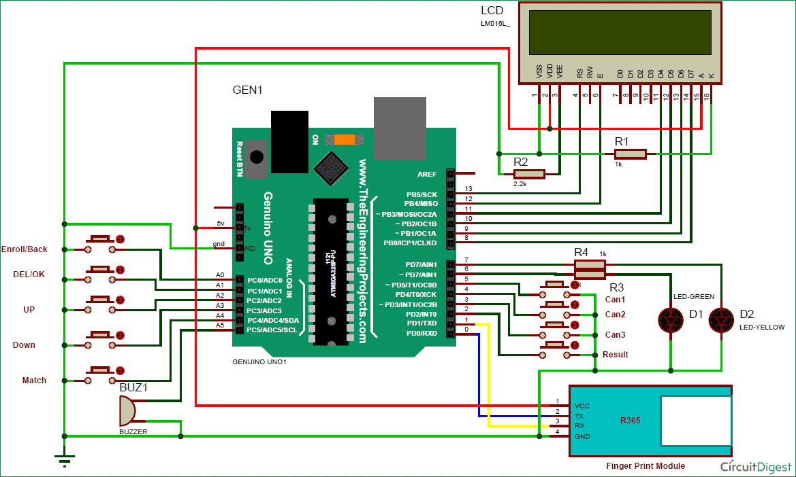

* 1. **STRENGTHS AND WEAKNESSES:**

#### Biometric Accuracy:

**Advantage:** Fingerprint recognition is known for its high accuracy in identifying individuals. The uniqueness of fingerprints reduces the likelihood of false positives or negatives, enhancing the integrity of the voting process.

#### Fraud Prevention:

**Advantage:** Fingerprint-based systems can significantly reduce the risk of voter fraud, as it is difficult for individuals to impersonate someone else by replicating their fingerprints.

#### Enhanced Security:

**Advantage:** The integration of biometric data adds an extra layer of security, making it more challenging for unauthorized individuals to gain access to the voting system.

#### Efficiency in Verification:

**Advantage:** Fingerprint verification is typically quicker than manual identity checks, leading to faster and more efficient voter authentication.

#### Uniqueness and Non-Transferability:

**Advantage:** Fingerprint characteristics are unique to each individual and cannot be easily transferred or shared, further ensuring the authenticity of the voter.

**Weaknesses:**

#### Privacy Concerns:

**Challenge:** The collection and storage of biometric data, including fingerprints, raise privacy concerns. Voters may be apprehensive about sharing such sensitive information.

#### Technical Challenges:

**Challenge:** Technical issues, such as sensor malfunctions or software errors, can hinder the smooth operation of fingerprint-based voting systems.

#### Cost of Implementation:

**Challenge:** Implementing and maintaining a fingerprint-based voting system can be expensive, involving the cost of biometric devices, secure databases, and ongoing system maintenance.

#### Limited Accessibility:

**Challenge:** Some individuals, particularly the elderly or those with certain medical conditions, may face challenges in providing clear fingerprints, potentially limiting the inclusivity of the system.

* 1. **OPPORTUNITIES AND THREATS:**

## Opportunities:

#### Public Trust and Confidence:

**Opportunity:** A well-implemented fingerprint-based voting system can enhance public trust in the electoral process, as it provides a more secure and tamper-resistant voting environment.

#### Integration with Digital Systems:

**Opportunity:** Fingerprint technology can be seamlessly integrated into digital voting systems, providing a foundation for future technological advancements in the electoral domain.

#### International Adoption:

**Opportunity:** Successful implementation in one region or country may encourage others to adopt similar fingerprint-based voting systems, promoting a standardized and secure approach to elections.

## Threats:

#### Security Risks:

**Threat:** Despite being more secure than traditional methods, fingerprint systems are not immune to hacking or data breaches. Security measures must be robust to protect against potential threats.

#### Legal and Ethical Issues:

**Threat:** Legal and ethical concerns, such as the misuse of biometric data, inadequate consent processes, or discriminatory practices, could lead to public backlash and legal challenges.

#### Resistance and Public Perception:

**Threat:** Resistance from the public due to privacy concerns or a lack of understanding about the technology could hinder the widespread adoption of fingerprint-based voting systems.

#### Technological Limitations:

**Threat:** Rapid advancements in technology may render fingerprint-based systems obsolete or less secure over time, necessitating ongoing updates and improvements.

**CHAPTER 4**

**DESIGN AND IMPLEMENTATION OF FINGERPRINT-BASED VOTING SYSTEMS**

# INPUT

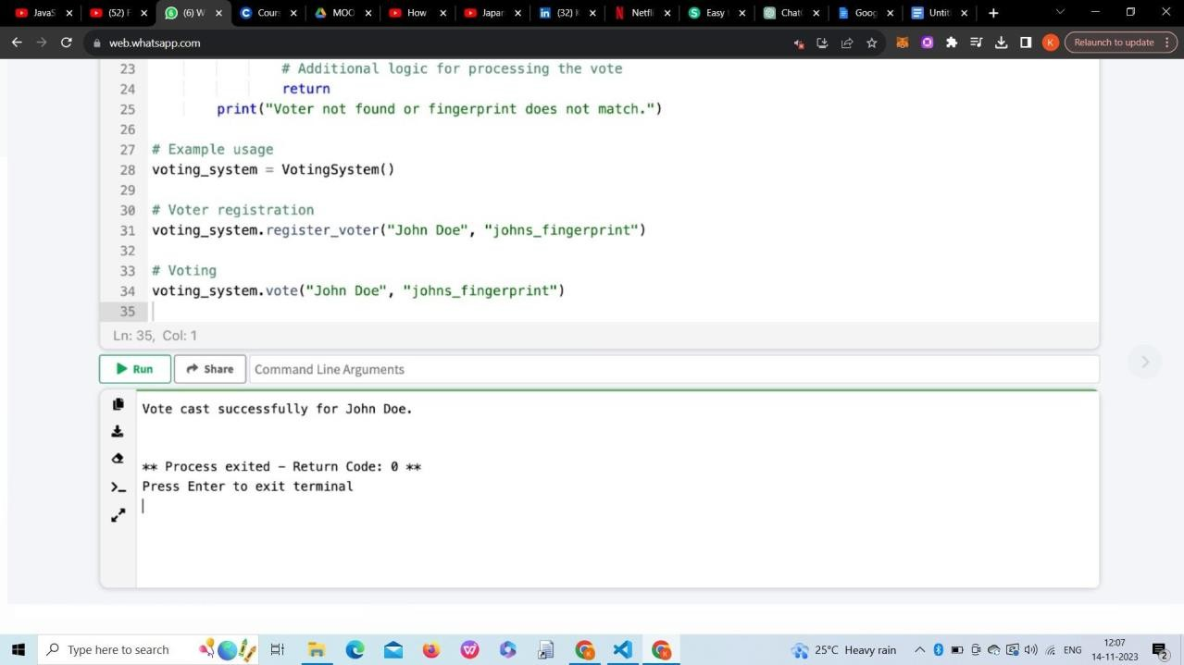



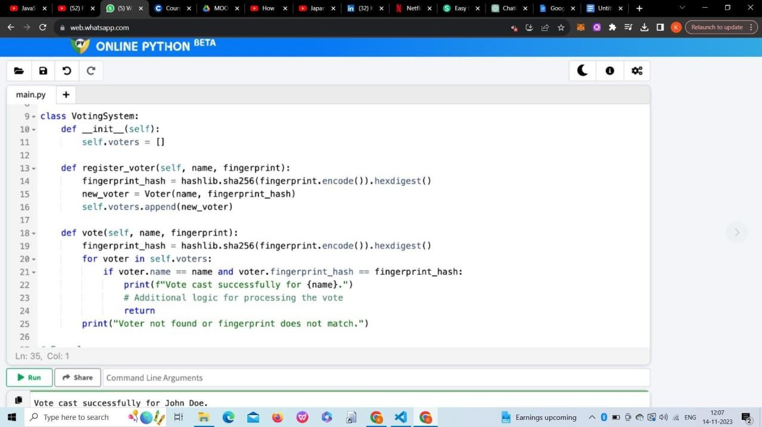

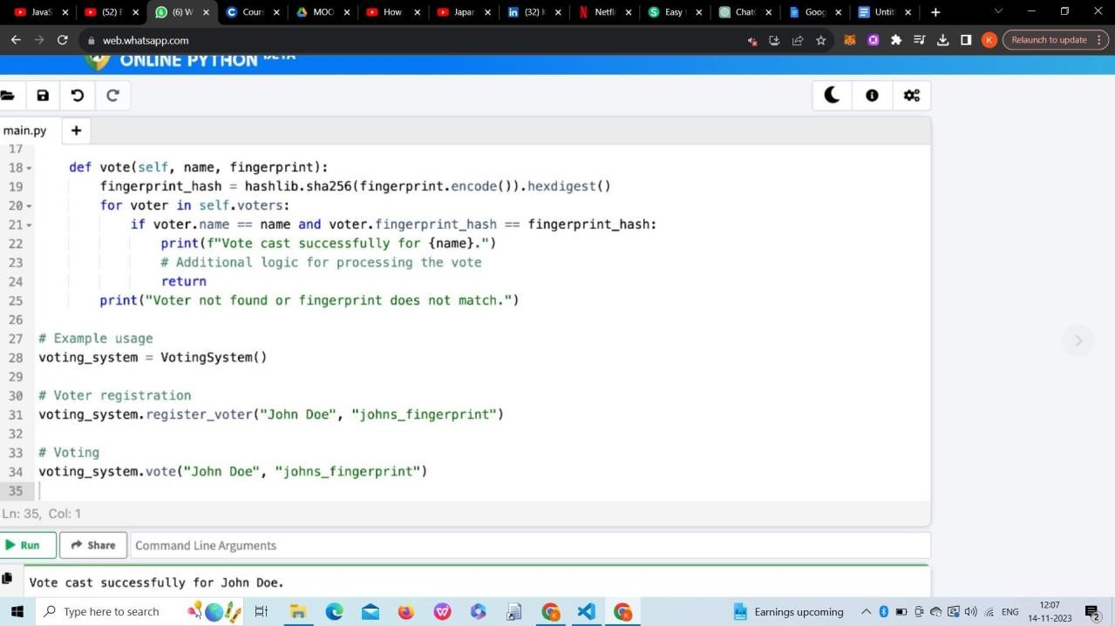

**CHAPTER 5 RESULTS AND DISCUSSION**

* 1. **PERFORMANCE ANALYSIS:**

# OUTPUT

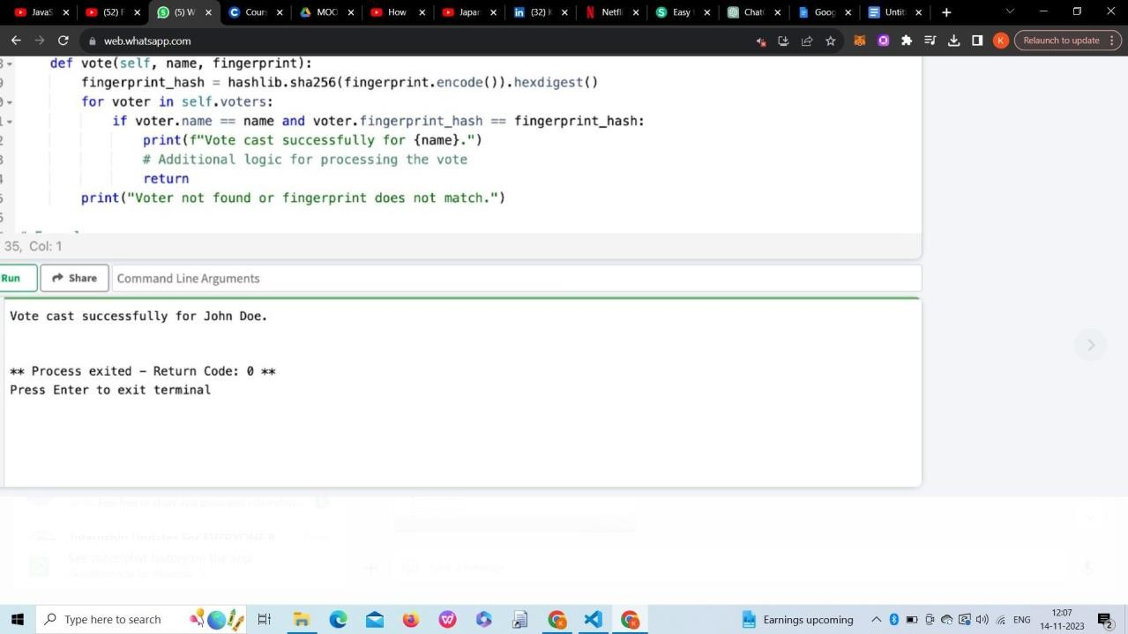

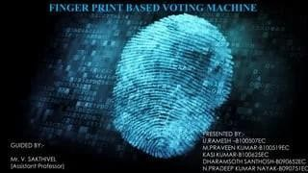

### DISCUSSION OF EXISTING MODELS:

#### Integrated Biometric Voting System:

**Description:** This model integrates fingerprint recognition directly into the voting machine. Voters provide their fingerprints, and the system verifies their identity before allowing access to the voting interface.

**Advantages:** Streamlines the voting process by combining identification and voting into a single system. Reduces the need for separate verification steps.

#### Mobile-Based Fingerprint Voting:

**Description:** Utilizes mobile devices with built-in fingerprint scanners. Voters register their fingerprints on their smartphones, and the mobile app is used for both enrollment and voting.

**Advantages:** Increases accessibility, as voters can use their own devices. Can potentially reduce infrastructure costs associated with traditional voting machines.

#### Centralized Biometric Database:

**Description:** Establishes a centralized database containing registered voters' biometric information, including fingerprints. Voting stations connect to this database for real-time verification.

**Advantages:** Enhances security by centralizing the biometric data. Allows for real-time updates and ensures consistency across voting locations.

#### Hybrid Biometric Systems:

**Description:** Combines multiple biometric modalities, such as fingerprints and facial recognition, for voter verification. This hybrid approach aims to improve accuracy and address challenges associated with a single biometric modality.

**Advantages:** Offers a more robust identification process by leveraging the strengths of multiple biometric technologies. Reduces the risk of false positives and negatives.

#### Blockchain-Based Fingerprint Voting:

**Description:** Integrates blockchain technology for secure and transparent recording of votes. Fingerprint verification is combined with a blockchain ledger to ensure the integrity of the voting process.

**Advantages:** Enhances transparency and tamper resistance. Provides a verifiable and immutable record of votes.

#### Biometric Voter Registration Kiosks:

**Description:** Dedicated kiosks for voter registration equipped with fingerprint scanners. During the registration process, voters' fingerprints are captured and linked to their voter ID.

**Advantages:** Separates the enrollment process from the actual voting, allowing for a more focused and efficient workflow during elections.

#### Cloud-Based Fingerprint Voting:

**Description:** Stores fingerprint templates in a secure cloud-based repository. Voting machines connect to the cloud for identity verification, allowing for centralized management of voter data.

**Advantages:** Enables scalability and ease of maintenance. Offers the potential for real-time updates and synchronization of voter information.

**CHAPTER 6 CONCLUSION AND FUTURE SCOPE**

### PERFORMANCE ANALYSIS:

The fingerprint-based voting system represents a significant advancement in the realm of electoral technology, aiming to address various challenges associated with traditional voting methods. The utilization of biometric data, specifically fingerprints, provides a secure and efficient means of verifying voter identity, thereby enhancing the overall integrity of the electoral process. This conclusion is drawn from an analysis of the strengths, weaknesses, opportunities, and threats associated with fingerprint-based voting systems.

The strengths of such systems lie in their biometric accuracy, capability to prevent fraud, enhanced security measures, efficiency in voter verification, and the unique and non-transferable nature of fingerprints. These attributes contribute to a more reliable and tamper-resistant voting environment. Moreover, the opportunities presented by fingerprint-based systems include the potential to build public trust, integrate with digital systems, and inspire international adoption, thereby promoting standardized and secure electoral practices.

However, certain weaknesses and threats must be acknowledged. Privacy concerns, technical challenges, the cost of implementation, and potential limitations in accessibility highlight areas where careful consideration and mitigation strategies are necessary. Moreover, legal and ethical issues, security risks, public resistance, and the possibility of technological advancements impacting the effectiveness of fingerprint systems must be actively addressed.

The success of fingerprint-based voting systems hinges on a comprehensive understanding and management of these factors. Striking a balance between the need for heightened security and addressing privacy concerns is crucial. Moreover, ongoing technological advancements and regulatory frameworks should be considered to ensure the adaptability and longevity of these systems. Public awareness and education about the benefits and safeguards associated with fingerprint-based voting can foster acceptance and trust.

In essence, while fingerprint-based voting systems hold great promise in revolutionizing electoral processes, their implementation requires a multidimensional approach that encompasses technological innovation, legal compliance, ethical considerations, and public engagement. As the landscape of electoral technology continues to evolve, fingerprint-based voting systems represent a significant stride towards more secure, transparent, and efficient democratic practices.

### FUTURE SCOPE:

The future scope for fingerprint-based voting systems is vast, as advancements in technology and a growing emphasis on secure and efficient electoral processes continue to shape the landscape of democratic practices. Several potential avenues indicate the promising trajectory of fingerprint-based voting systems:

#### Enhanced Integration with Emerging Technologies:

Future systems could integrate fingerprint recognition with other emerging biometric technologies, such as facial recognition or iris scanning, to create more robust and multi-modal verification processes. This can further enhance accuracy and security. Blockchain Integration for Transparency:

The incorporation of blockchain technology offers the potential for creating transparent, secure, and tamper-proof voting systems. Fingerprint data, along with vote records, could be securely stored on a blockchain, ensuring the integrity of the entire electoral process.

#### Mobile and Remote Voting Applications:

Fingerprint-based voting systems could expand to include mobile applications, allowing voters to authenticate themselves and cast their votes remotely. This could increase accessibility, especially for individuals with mobility issues or those residing in remote locations.

#### Biometric Data Protection and Privacy Measures:

Future developments should focus on implementing robust data protection measures and addressing privacy concerns associated with biometric data. Innovations in secure storage, encryption techniques, and decentralized identity management systems could be explored.

#### Global Standardization and Interoperability:

Efforts towards establishing global standards for fingerprint-based voting systems and ensuring interoperability can facilitate international adoption. This would enable consistency and compatibility across different regions, enhancing the efficiency of electoral processes.

#### Continuous Technological Upgrades:

Ongoing research and development will likely lead to more advanced fingerprint recognition algorithms and hardware. Continuous technological upgrades can improve accuracy, speed, and the overall reliability of fingerprint-based voting systems.

#### User-Friendly Interfaces and Accessibility Features:

Future systems should prioritize user-friendly interfaces to ensure inclusivity and ease of use for voters of all ages and backgrounds. Accessibility features, such as voice assistance and tactile interfaces, can further enhance the inclusiveness of these systems.

#### Machine Learning for Fraud Detection:

Implementing machine learning algorithms can enhance the ability of fingerprint- based voting systems to detect anomalies or fraudulent activities. Continuous learning from patterns and behaviors can contribute to a more adaptive and resilient system.

#### Integration with National Identification Systems:

Collaboration with existing national identification systems can streamline voter registration and verification processes. Aligning fingerprint-based voting systems with established identity databases can improve accuracy and reduce redundancy.

#### Public Awareness and Trust-Building Campaigns:

Fostering public awareness and trust in fingerprint-based voting systems is crucial for their widespread acceptance. Future initiatives could focus on comprehensive education campaigns to inform the public about the benefits, security measures, and ethical considerations associated with these systems.

The future scope for fingerprint-based voting systems is dynamic, driven by technological innovations, regulatory advancements, and a commitment to enhancing the democratic process. As these systems evolve, they have the potential to contribute significantly to secure, transparent, and inclusive electoral practices worldwide.

### REFERENCES:

#### Fingerprint Base Electronic Voting System – Research gate

[www.researchgate.net/profile/Haydar-](http://www.researchgate.net/profile/Haydar-Mohammed/publication/268657819_FingerPrint_Base_Electronic_Voting_System/links/5472eedc0cf216f8cfae909a/FingerPrint-Base-Electronic-Voting-System.pdf?origin=publication_detail) [Mohammed/publication/268657819_FingerPrint_Base_Electronic_Voting_Syste](http://www.researchgate.net/profile/Haydar-Mohammed/publication/268657819_FingerPrint_Base_Electronic_Voting_System/links/5472eedc0cf216f8cfae909a/FingerPrint-Base-Electronic-Voting-System.pdf?origin=publication_detail) [m/links/5472eedc0cf216f8cfae909a/FingerPrint-Base-Electronic-Voting-](http://www.researchgate.net/profile/Haydar-Mohammed/publication/268657819_FingerPrint_Base_Electronic_Voting_System/links/5472eedc0cf216f8cfae909a/FingerPrint-Base-Electronic-Voting-System.pdf?origin=publication_detail) [System.pdf?origin=publication_detail](http://www.researchgate.net/profile/Haydar-Mohammed/publication/268657819_FingerPrint_Base_Electronic_Voting_System/links/5472eedc0cf216f8cfae909a/FingerPrint-Base-Electronic-Voting-System.pdf?origin=publication_detail)

#### Fingerprint Based Biometric Voting Machine Using Arduino.” Fingerprint Based Biometric Voting Machine Project Using Arduino,

circuitdigest.com/microcontroller-projects/fingerprint-based-biometric-voting- machine-arduino

#### Fingerprint-Based-Voting-System. GitHub

github.com/ssr197/Fingerprint-Based-Voting-System.